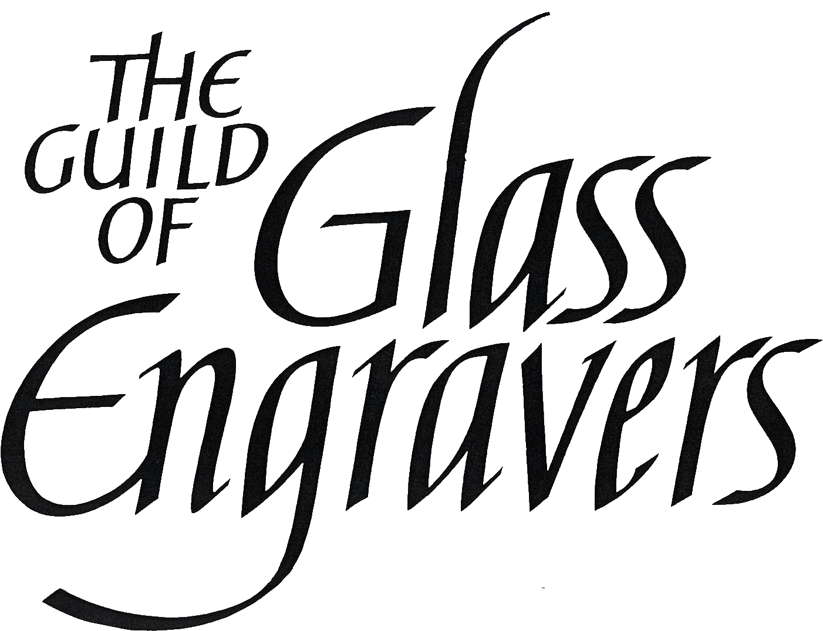

**Part-time Administrator - The Guild of Glass Engravers**

**Job Description 2022**

An exciting opportunity for flexible working from home.

£12.50 per hour, 12 hours per week, (£7,800 pa).

20 working days holiday per annum pro rata

The ability to attend very occasional meetings (no more than 5 a year) possibly on a Saturday in person in either central London or Winchester is essential. Currently all meetings are online on zoom.

You should have proficient computer skills, including MS Word, Excel, Outlook, and experience of updating websites and social media accounts.

You will be responsible for the day to day running of the Guild, including its membership, accounts, liaising with Guild officers and enquiries from the public. You will process invoices and payments.

In summary your duties will be to:

**Membership**

* Welcome new members, send out information packs, record subscription payment and include new details on our databases.
* Manage renewal of membership at year end, recording which members have renewed their subscription via PayPal, bank transfer, credit card payment or cheque and seek renewal from those members who have not made their payment.
* Track the progress of member assessments and reporting the outcome to the Council for ratification, and to the member.
* Respond to members’ queries and requests for information.

**Marketing**

* Ensure Guild news and events are circulated via the Guild’s social media sites.
* Work with the Guild web manager to keep the website up to date.
* Produce regular mailings for members using Mailchimp.
* Produce 3 x newsletters per year compiling news and opportunities, designing layout and circulating to members online and via post.
* Posting out annual Spring Special to all members with subscription letter.
* Develop online lecture series.
* Promote Guild activities on social media and through newsletters

**Meetings and Events**

* Council Meetings via zoom– arrange the meeting, create and send out link with the approved agenda, take minutes at the meetings, type up the minutes for circulation to the Council.
* Guild Conference and AGM on zoom - arrange, circulate link and invite members and ensure speakers are booked. Welcome members and guests on the day and ensure the event runs smoothly.
* Biennial Guild Exhibition – book venue, insurance and display equipment for the event. Invite the audience and promote the event. Assist with ad-hoc administration for the event. Research and develop exhibition in Winchester.
* Making Your Mark and David Peace Prize - administer student online exhibition

**Finance**

* Update all bank mandates appropriately, check bank statements, set up all online payments and PayPal transfers. Input payments and manage invoices.
* Liaise with Guild Treasurer in order to produce year end accounts.
* Submit monthly PAYE details and payments to HMRC.
* Charities Commission – employee to be appointed as authorised person and annual report to be submitted.
* Artists General Benevolent Institute – request donations from members and submit to the AGBI annually.

**Office and Additional Duties**

* Assist with the organisation of Guild biennial exhibitions and events
* Purchase office stationary.
* Manage emails including commission enquiries and general enquiries from the public.
* Website – confirm that member details are up to date and web sale stock is available.
* Process book sales.
* Back up the Guild computer onto the hard drive.
* Renew virus protection.
* Renew annual insurance.
* Maintain relationships with key partners and organisations including Craft UK network.

The employee will report to the Chairman.

**Person Specification**

The ideal candidate is a self-motivated, proactive individual with an understanding of the creative industries and a commitment to outstanding customer service.

A positive ‘can do’ attitude is required.

Minimum qualification requirement is GCSE qualification in English and Mathematics.

Education to degree level is desirable.

Excellent written and spoken English is essential.

Excellent attention to detail is essential.

Strong, proven administration skills are essential.

Experience of working within the creative industries / charity sector is desirable.

Experience of working with designer-makers is desirable.

Experience in exhibition / event logistics is desirable.

Knowledge of MailChimp, BrightPay is desirable.

The employee will need to have appropriate office space within their home to house the Guild laptop computer, a small number of files, a small amount of stock, stationery and archive material.

**Interviews will take place on Zoom.**

**Two references will be required. Please include the names and contact details of two people who can be contacted for references if you are successful in your application.**

**One must be your current or most recent employer.**